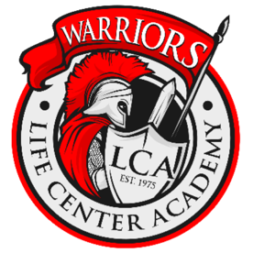
Life Center Academy
2045 Columbus Road
Burlington, NJ 08016
(609) 499-2100

Student Reference Form (Confidential)
This form must be completed by a current teacher, administrator, or pastor who knows the student well. It may not be completed by a parent, guardian, family member, or the student. All information is confidential and must be submitted directly to the Admissions Office, not returned to the applicant or family.

Student Name: Grade Applying For:
Reference Name: Title/Position:
School/Church Name: Email:
Phone: Years Known: Capacity Known:

Academic Evaluation (mark one):
Academic effort: Excellent Good Average Needs Improvement
Work habits: Excellent Good Average Needs Improvement
Completes work: Excellent Good Average Needs Improvement
Follows instructions: Excellent Good Average Needs Improvement

Character & Conduct (mark one):
Respect for authority: Excellent Good Average Needs Improvement
Integrity / Honesty: Excellent Good Average Needs Improvement
Peer relationships: Excellent Good Average Needs Improvement
Response to correction: Excellent Good Average Needs Improvement

Please answer briefly:
Academic Strength(s):

Areas for Growth:

Behavior/Conduct concerns (if any):

Spiritual/Christian Character (optional but helpful):

Overall recommendation (check one):
Strongly Recommend Recommend With Reservations Do Not Recommend

Additional Comments (optional):

Certification: I certify that I am currently a teacher, administrator, or pastor and that this information is true to the best of my knowledge. Signature: Date:

Please return this completed form directly to the Life Center Academy Admissions Office.
Email: admissions@lcmail.org Subject Line: Student’s Full Name | Or mail to the school address above

